

Internet Programming

Final Project Report



***Team Members***

Mohamed Adel Lotfy 18P1724

Adel Asaad Sarofeim 18P2949

Abdelrahman Tarek Mahdy 18P7159

***Chosen Topic***Online Library

***Supervisor***

Dr. Hesham Farag

# Home Page:

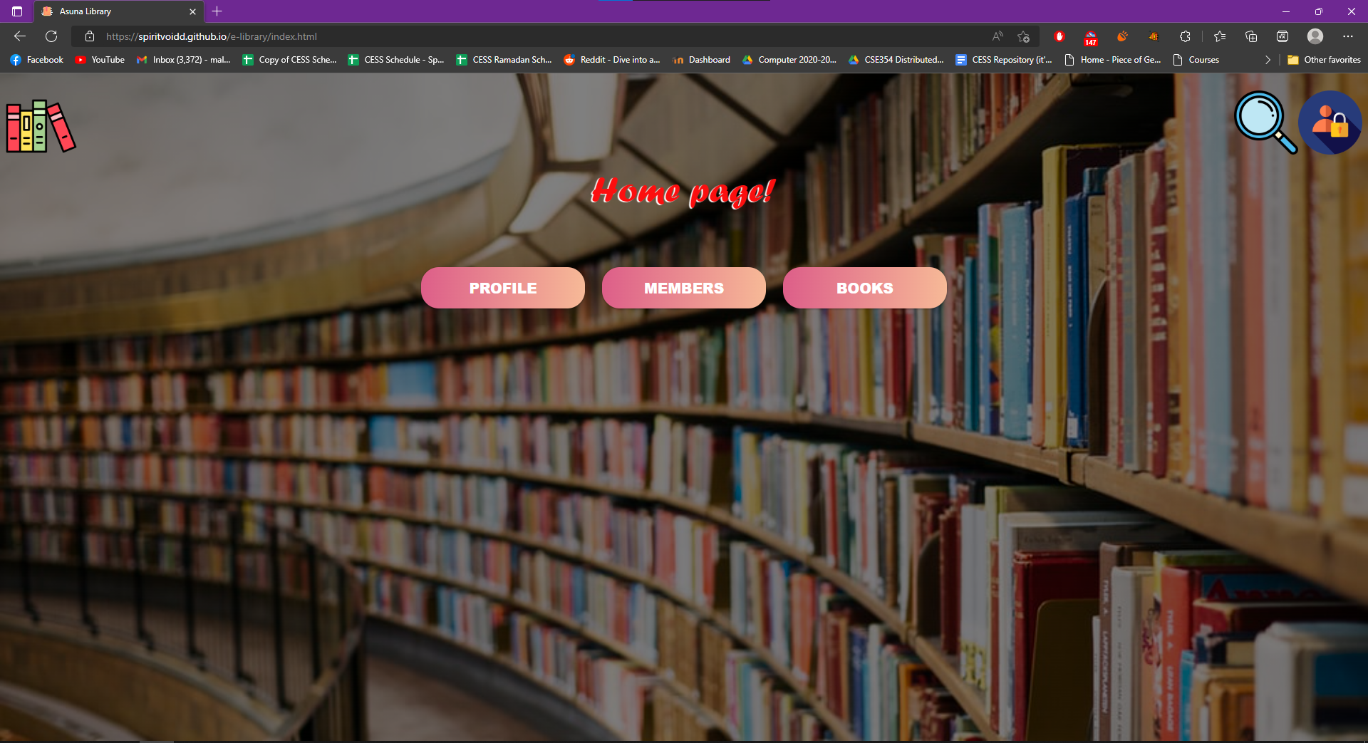

Contents of the page:

## Search button:

This button takes the user to the search page.